Year 5 Knowledge Organiser: History – Ancient Greece
Subject Specific Vocabulary |  | What should I already know?
assembly | A group of citizens who turned up to vote. | - Have an awareness of the past, using common words and phrases relating to the passing of time.  - Be able to identify similarities and differences between ways of life in different periods.  - Use a wide vocabulary of everyday historical terms.  - Be able to ask and answer questions, choosing and using parts of stories and other sources to show that you know and understand key features of events.  - Understand some of the ways in which we find out about the past and identify different ways in which it is represented.  Sticky knowledge  - The Ancient Greek Civilisation began in 800BC  - The Greeks invented the Olympic Games  - Religion was very important in Ancient Greece. They were polytheists - they believed in different gods and goddesses that were in charge of different parts of their lives, such as a god of the sea and a goddess of wisdom.  - Temples were built in their honour and they featured heavily in the stories of Greek mythology  - In Athens, Greek styles of art, architecture, philosophy and theatre were developed.  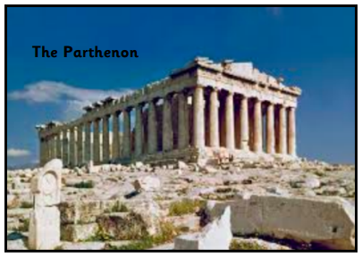  - Athens had a democratic government – this means that the people who lived there made decisions by voting, like we do in Britain.  - In Sparta, life was very different; all that was important was being able to defend Sparta in battle.
citizens | An inhabitant of a town or city
democracy | A form of government where citizens have a say in how they are ruled.
tyranny | A cruel or oppressive government or rule.
Minoans | Greeks who developed palace centred civilisation.
Mycenaean | Civilisation that first developed Greek culture.
Gods and Goddesses | Male and female deity from the ancient Greek pantheon.
Olympics | An athletic event held every 4 years.
enslaved | To make someone a slave causing them to lose their freedom.
mythology | A traditional story explaining the history of people or a natural phenomenon.
architecture | The art or practise of designing and constructing buildings.
philosophy | The study of the fundamental nature of knowledge, reality and existence.
Spartans | A tough warriors living in the Greek city of Sparta.
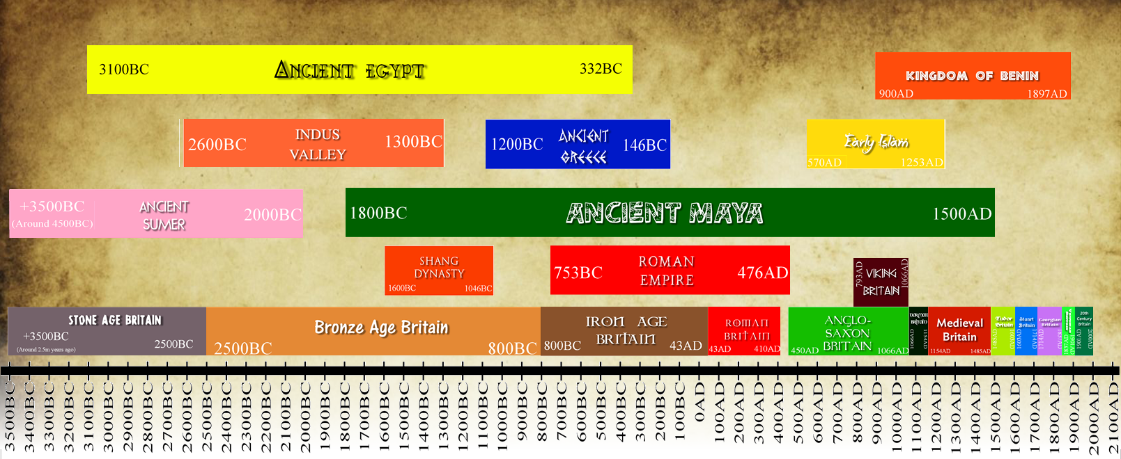  polis | A city state.

Year 5 Knowledge Organiser: History – Ancient Greece
Subject Specific Vocabulary |  | What should I already know?
assembly | A group of citizens who turned up to vote. | - Have an awareness of the past, using common words and phrases relating to the passing of time.  - Be able to identify similarities and differences between ways of life in different periods.  - Use a wide vocabulary of everyday historical terms.  - Be able to ask and answer questions, choosing and using parts of stories and other sources to show that you know and understand key features of events.  - Understand some of the ways in which we find out about the past and identify different ways in which it is represented.  Sticky knowledge  - The Ancient Greek Civilisation began in 800BC  - The Greeks invented the Olympic Games  - The Greek Gods lived on Mount Olympus  - The Greeks gave us lots of Myth and Legend stories  - Alexander the Great was the King of Ancient Greece  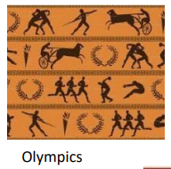
citizens | A town or city where people live.
democracy | Where citizens have a say in how they are ruled.
tyranny | Cruel government or rule.
Minoans | Greeks who developed palaces.
Mycenaean | Civilisation that first developed Greek culture.
Gods and Goddesses | Male and female deity (ruler) from the pantheon.
Olympics | An athletic event held every 4 years.
enslaved | To make someone a slave.
mythology | A traditional story explaining the history of people.
architecture | Designing and constructing buildings.
philosophy | The study of knowledge and existence.
Spartans | A tough warrior living in the Greek city of Sparta.
polis | A city state.

