
Year 1 Knowledge Organiser: Geography and History – Holidays

Subject Specific Vocabulary |  | Examples
holiday | Some time away from home. | 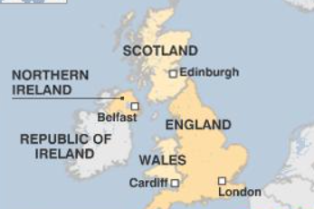    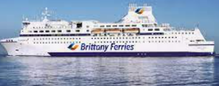  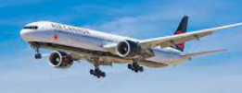  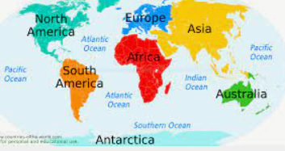  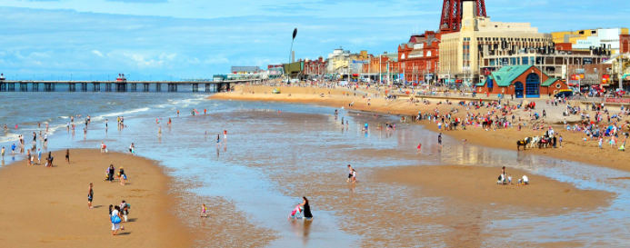  Assessment questions  Where did people used to go on holiday? Where do people go on holiday now? What are the 4 countries in the U.K? What are the 7 continents? What are the 5 oceans? Where might people living in Heywood go on holiday in the U.K?
sea-side | Where the sea meets land.
beach | Sand next to the sea.
sea | The large mass of water next to the land.
abroad | A place not in the U.K.
U.K. | An island made up of 4 countries.
country | A nation with its own government.
continent | The world’s main bits of land.
aeroplane | A mode of transport that flies through the sky.
boat | A mode of transport that travels on water.
past | Something that has already happened.
present | Something that is happening now.
ocean | A very large amount of sea.

