Year Group: 3  Term: Spring 1 | 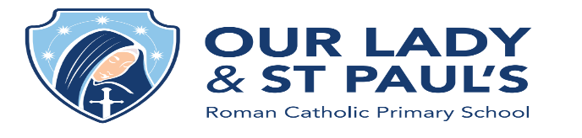
This term’s school virtues are:
Faith and Simplicity

Religious Education
Journeys – Christian Family’s Journey with Jesus
World Religion – Judaism
Maths  - Fractions, decimals, percentages  - Angles – measuring/drawing  - Statistics – line graphs/pictograms  - Four operations  - Times table focus 7s and 9s | English  Our class read for this half term is The Nothing To See Here Hotel  Talk For Writing Units  - Fiction: Finding Tale  - Non-Fiction: News Recount
Science  Bones and Muscles  - Learn that bones support and protect our bodies  - Learn that muscles move our bodies  - Understanding how muscles are used to move and support the body | History/Geography  The Romans  - Boudicca  - Lasting Legacy of the Romans  - Roman Life
PE  - Invasion games  - Inclusive PE  - Attack and defend | Computing  This half term we will be learning to send, respond to, and forward emails using online providers, as well as detect unsafe emails. We will also take part in an Online Safety Day.
Music  - Create and evaluate reggae music | MFL  - Animals
Things to remember

- Homework is given out on Fridays to be collected the following Friday
- 5 spellings will be given per week, focusing on a rule or a set of statutory spellings
- Lunches to be ordered via Evolve for Years 1-6
- All letters and further communication from school via Parentmail

