|  |  |  |
| --- | --- | --- |
| **Year 2 Knowledge Organiser: History – Significant individuals** | | |
| ***Subject Specific Vocabulary*** | | ***Examples*** |
| **Crimean war** | (1853 - 1856) A war between Russia on one side and Britain, France, the Ottoman Empire (Turkey) and Kingdom of Sardinia on the other. | Causes of the Crimean War - Historic UK  Mary Seacole | Biography, Facts, Family, &amp;amp; Nursing | BritannicaFlorence Nightingale Memorial Medal, presented to Helen G. McArthur, 1957.  | History of nursing, Red cross, Nurse rock |
| **Chronological** | In order that the events happened |
| **nurse** | Someone who is trained to care for the sick |
| **discrimination** | The unfair treatment of someone because of their race, colour, faith, or another group that you belong to |
| **medal** | A metallic disc awarded to someone for achieving something |
| **hospital** | Somewhere that provides care for the sick and injured |
| **timeline** | An image that has important events mapped out in **chronological** order |

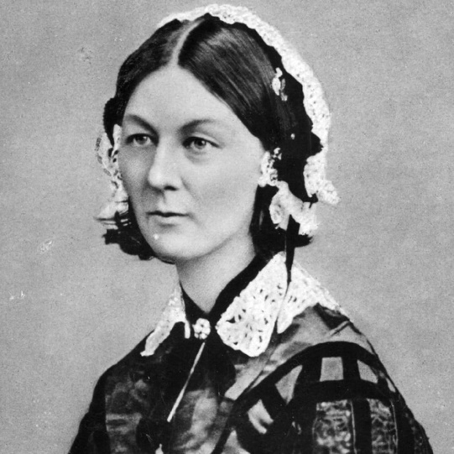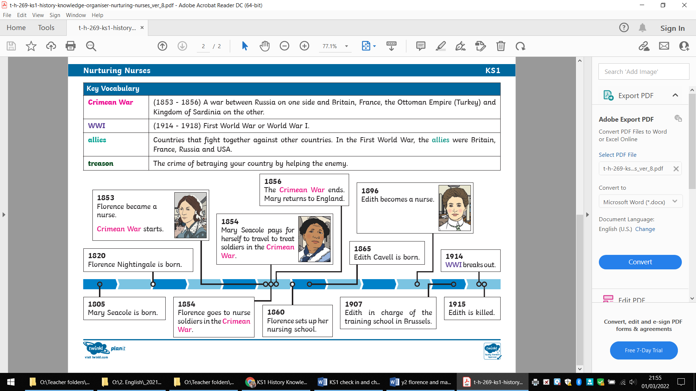

|  |  |  |  |
| --- | --- | --- | --- |
| **Year 2 Knowledge Organiser: History – Significant individuals** | | | |
| ***Subject Specific Vocabulary*** | | | |
| **Crimean war** | (1853 - 1856)  Causes of the Crimean War - Historic UKA war between Russia  on one side and  Britain (and others) | **hospital** | Mary Seacole | Biography, Facts, Family, &amp;amp; Nursing | BritannicaSomewhere that provides  care for the sick and  injured |
| **Chronological** | Chronological orderIn order that the  events happened | **timeline** | An image that has important events mapped out in  **chronological** order |
| **nurse** | C:\Users\amcglade\AppData\Local\Microsoft\Windows\INetCache\Content.MSO\4FE016CA.tmpSomeone who is trained  to care for the sick |  | |
| **discrimination** | International Day for the Elimination of Racial Discrimination 2021 |  Sustainable Development Goals - Resource CentreThe unfair treatment  of someone |
| **medal** | Florence Nightingale Memorial Medal, presented to Helen G. McArthur, 1957.  | History of nursing, Red cross, Nurse rockA metallic disc  Awarded to someone |