Use our curiosity to understand the world around us

Resilient learners- child led learning

Opportunity to question

Encourage independence

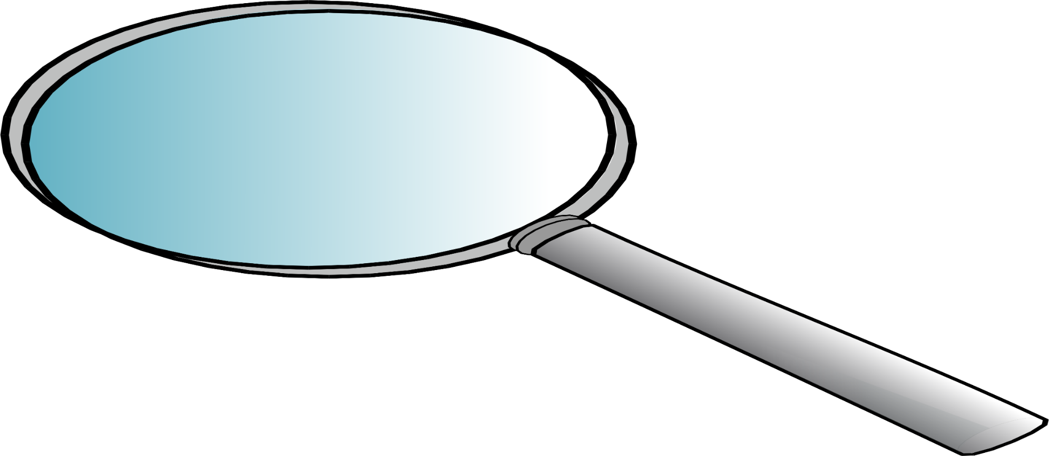



Investigate for themselves- build on prior knowledge

Science at Our Lady

Articulate themselves using scientific language

and St Pauls

Linked to real life- exploring the world

Hands on and challenging, developing awe and wonder

Develop working scientifically through5 types of enquiry

Science provides the foundation for understanding the world around us. It can not only teach pupils about the world they live in, but also how to study it and make sense of various phenomena. As such, it is a fundamental aspect of all children’s learning.

The teaching of science at Our Lady and St Pauls RC Primary School should encourage children to explore and appreciate the world which God has created, providing them with a sense of wonder about the world which will help them to show respect and responsibility for their environment and all living things.

**AIMS OF SCIENCE POLICY**

Our Science Policy follows The National Curriculum 2014 for Science Guidelines and aims to ensure that all pupils:

develop **scientific knowledge and conceptual understanding** through the specific disciplines of biology, chemistry and physics

develop understanding of the **nature, processes and methods of science** through different types of science enquiries that help them to answer scientific questions about the world around them

are equipped with the scientific knowledge required to understand the **uses and implications** of science, today and for the future.

Develop the ability to pose questions, investigate these using correct techniques, accurately record their findings using appropriate scientific language and analyse their results.

Helping pupils develop the skills of prediction, hypothesising, experimentation, investigation, observation, measurement, interpretation and communication.

Making pupils aware of and alert to links between science and other school subjects, as well as their lives more generally.