
Our Lady & St Paul’s R.C. Primary School,
A Voluntary Academy

Behaviour Policy

Issue No | Author/Owner | Date Written | Approved by Governors | Comments
1 | H.Aspinall | 8.12.25

Mission Statement

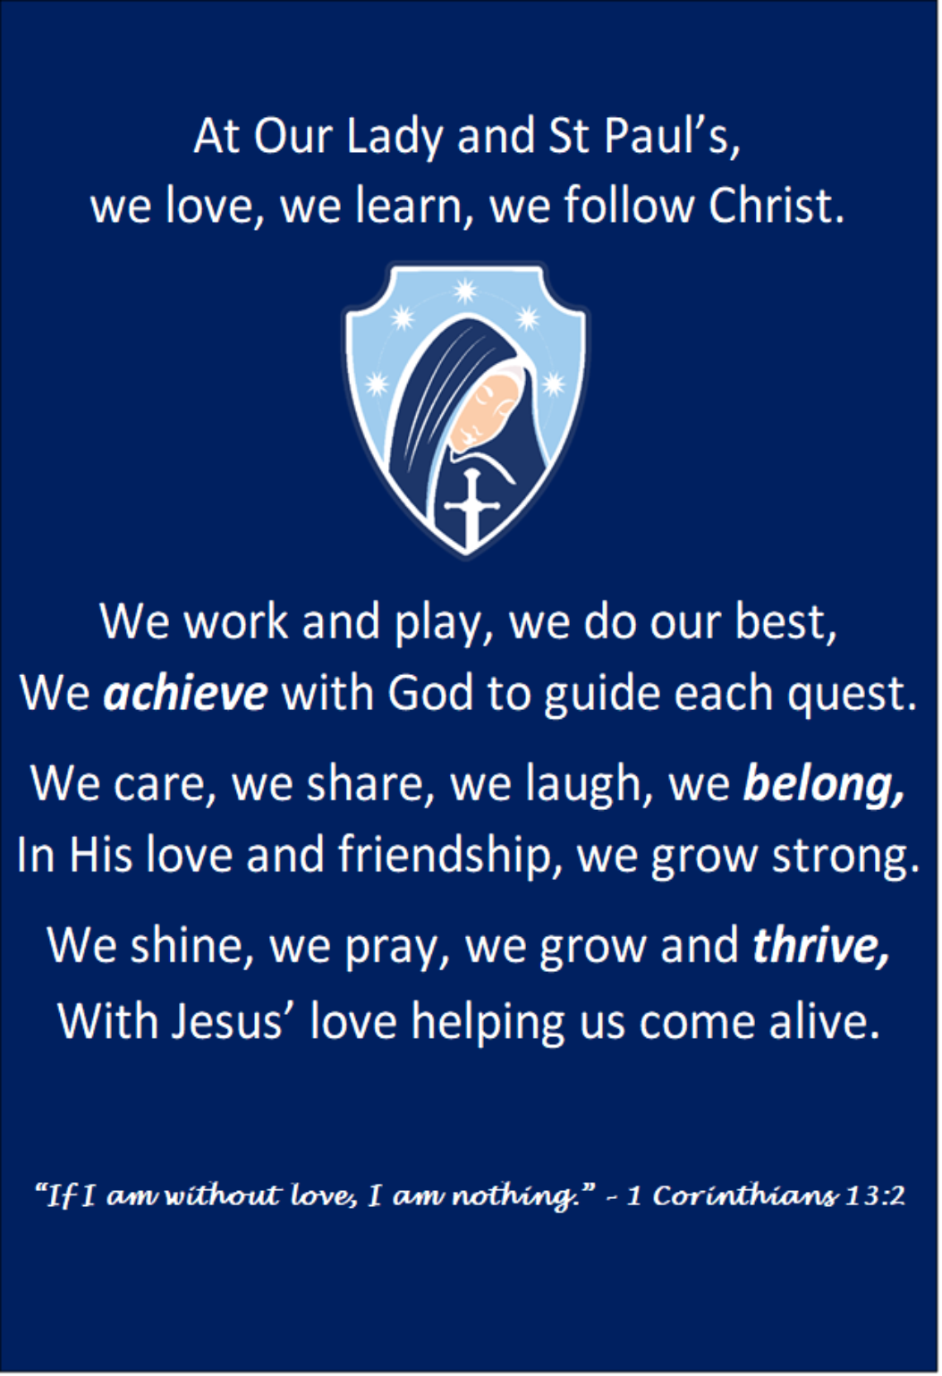

Our behaviour policy seeks to nurture a community rooted in Gospel values of love, respect, forgiveness and reconciliation.
We are committed to creating a culture in which every pupil feels safe, valued and ready to learn. We believe that when adults model calm, consistency and respect, children flourish. Inspired by Paul Dix’s principles in “When the Adults Change, Everything Changes”, we foster a shared language of expectations:
We are Ready, Respectful and Safe.

Aims and Principles
At Our Lady & St Paul’s RC Primary School, we believe that good behaviour stems from strong relationships, clear boundaries, and mutual respect.
Our approach is restorative and positive, not punitive. We seek to repair harm and rebuild trust through reconciliation and reflection.
Our behaviour principles are underpinned by the following beliefs:
- Every person is created and loved by God, deserving of dignity and respect.
- A culture of forgiveness and reconciliation allows for growth and renewal each day.
- Everyone in our community feels happy, safe, valued, and secure.
- Consistency, calmness, and compassion build trust and high expectations.
- The language of Ready, Respectful, Safe guides all our interactions.
These principles are not primarily about enforcing rules, but about fostering positive relationships and shared responsibility so that all can thrive.

Legal Framework
This policy has due regard to all relevant legislation and statutory guidance including, but not limited to:
- Education Act 1996
- Education Act 2002
- Education and Inspections Act 2006
- Equality Act 2010
- DfE (2022) Behaviour in Schools: Advice for Headteachers and School Staff
- DfE (2023) Keeping Children Safe in Education
- DfE (2022) Searching, Screening and Confiscation: Advice for Schools
- DfE (2023) Suspension and Permanent Exclusion guidance
This policy operates alongside the following school policies:
- SEMH Policy
- SEND Policy
- Anti-Bullying Policy
- Child Protection and Safeguarding Policy
- Physical Intervention Policy
- Complaints Procedures Policy
- Exclusions Policy
- Child-on-Child Abuse Policy

Roles and Responsibilities
The Governing Board will:
- Provide clear behaviour principles aligned with the Catholic ethos of the school.
- Ensure the policy promotes equality, dignity and inclusion.
- Support a whole-school culture of calm, dignity and structure.
- Review and publish this policy annually.
The Headteacher will:
- Model calm, consistent leadership in line with Ready, Respectful, Safe.
- Promote a restorative approach where relationships are repaired, not broken.
- Ensure all staff are trained and supported to apply this policy consistently.
- Report on the policy’s effectiveness to governors.
The SENCO and Mental Health Lead will:
- Support pupils with additional needs, ensuring early identification and effective interventions.
- Work closely with staff and families to provide appropriate support.
All Staff will:
- Model Ready, Respectful, Safe behaviour in every interaction.
- Use relational, restorative language that supports reflection and responsibility.
- Maintain calm authority and consistent expectations.
- Celebrate positive behaviour more frequently than they sanction poor behaviour.
- Work closely with parents and carers to support each child.
Pupils will:
- Strive to be Ready to learn, Respectful to all, and Safe in every action.
- Take responsibility for their choices and learn from mistakes.
- Seek reconciliation after conflict or wrongdoing.
Parents and Carers will:
- Support the school’s approach and reinforce Ready, Respectful, Safe at home.
- Communicate openly with staff about any factors affecting behaviour.
- Work in partnership with the school to promote positive outcomes.

Definitions and Expectations
For the purposes of this policy, the school will define “serious unacceptable behaviour” as any behaviour which may cause harm to oneself or others, damage the reputation of the school within the wider community, and/or any illegal behaviour. This will include, but is not limited to, the following:
- Discrimination – not giving equal respect to an individual on the basis of age, disability, gender identity, marriage and civil partnership, pregnancy and maternity, race, religion or belief, sex, and sexual orientation
- Harassment – behaviour towards others which is unwanted, offensive and affects the dignity of the individual or group of individuals
- Vexatious behaviour – deliberately acting in a manner so as to cause annoyance or irritation
- Bullying – a type of harassment which involves personal abuse or persistent actions which humiliate, intimidate, frighten or demean the individual being bullied
- Cyberbullying – the use of electronic communication to bully a person, typically by sending messages of an intimidating or threatening nature
- Possession of legal or illegal drugs, alcohol or tobacco
- Possession of banned items
- Truancy and running away from school
- Refusing to comply with disciplinary sanctions
- Theft
- Verbal abuse, including swearing, racist remarks and threatening language
- Fighting and aggression
- Persistent disobedience or disruptive behaviour
- Extreme behaviour, such as violence and serious vandalism
- Any behaviour that threatens safety or presents a serious danger
- Any behaviour that seriously inhibits the learning of pupils
- Any behaviour that requires the immediate attention of a staff member
For the purposes of this policy, the school will define “low-level unacceptable behaviour” as any behaviour which may disrupt the education of the perpetrator and/or other pupils, including, but not limited to, the following:
- Low-level disruption and talking in class
- Failure to complete classwork
- Rudeness
- Lack of correct equipment
- Refusing to complete homework, incomplete homework, or arriving at school without homework
- Use of mobile phones without permission

We view behaviour as a form of communication and a learning opportunity.
Unacceptable behaviour includes actions that disrupt learning, harm others, or undermine safety and respect.
Every incident is approached restoratively — focusing on understanding, reflection, and repai
Staff Induction and Development
All staff are inducted into our Ready, Respectful, Safe culture.
Training ensures that adults:
- Respond rather than react.
- Stay calm and consistent under pressure.
- Use restorative conversations to rebuild relationships.
- Understand how SEND and wellbeing impact behaviour.
We believe that when the adults change, everything changes.
Consistency and connection are key.

Social, Emotional and Mental Health (SEMH) Needs
As a nurturing Catholic community, we prioritise emotional wellbeing and inclusion.
We:
- Promote resilience and positive mental health for all.
- Use the curriculum, especially RE and RHE, to teach forgiveness, empathy and compassion.
- Engage families and external agencies where needed to ensure holistic support.

Recognising and Rewarding Positive Behaviour
At Our Lady & St Paul’s, we believe that recognition and encouragement are more powerful than punishment.
We aim to notice, name and nurture positive behaviour — helping pupils understand that being Ready, Respectful and Safe is valued and celebrated.
Our approach builds intrinsic motivation, encouraging children to make good choices because it is right and reflects Gospel values.
We celebrate effort, kindness, resilience, and living out Christ’s teachings.
Ways we recognise and reward positive behaviour include:
- Verbal Praise – frequent, specific and sincere acknowledgement of positive behaviour.
- Dojo Points – awarded for demonstrating effort, teamwork, and our school values.
- Individual Milestones – pupils earn badges as they reach key totals of Dojo Points:
  - Bronze Badge – first milestone achieved.
  - Silver Badge – continued positive effort and consistency.
  - Gold Badge – outstanding commitment to being Ready, Respectful and Safe.
Badges are presented and celebrated in assembly.
- Class Rewards – collective celebrations for achieving class milestones (e.g. 100, 200, 300 Dojos).
- Hot Chocolate with the Head – recognising pupils who consistently model Ready, Respectful, Safe in their daily actions.
- Certificates – awarded during our Feel Good Friday Assemblies to celebrate pupils who have gone above and beyond in showing kindness, effort, or living out our Gospel values.
- Positive Notes or Messages Home – sharing success with parents and carers.
Through these celebrations, every pupil leaves the week feeling noticed, valued, and proud to be part of our caring Catholic community.
Managing Behaviour Restoratively

When behaviour falls short of expectations, staff will:
- Remind – give a calm, clear reminder of expectations (Ready, Respectful, Safe).
- Reflect – hold a brief, private conversation to help the child think about their choice.
- Repair – use a restorative conversation to rebuild relationships and agree on positive next steps.
Sanctions may be used where appropriate — for example, loss of part or all of playtime, reflection time, or referral to a Key Stage Leader, Assistant Headteacher or Headteacher. All sanctions are delivered calmly, consistently and with dignity, ensuring that the child understands the reason for the consequence and the opportunity for reconciliation that follows.
Where a serious incident has occurred — such as swearing, fighting, persistent defiance, serious disruption, or refusal to follow instructions — a restorative meeting will take place involving the pupil and relevant staff.
Following this meeting:
- Parents or carers will be informed by telephone on the same day.
- The child will be asked to explain what has happened directly to their parent or carer during this phone call, supported by a staff member.
- The purpose of this conversation is to promote honesty, reflection, and responsibility, while strengthening the home–school partnership.
- The incident and follow-up action will be recorded.
Where serious or persistent incidents continue, the Headteacher may implement additional measures such as behaviour monitoring, individual support plans, or — in extreme cases — suspension, following DfE guidance and the school’s Suspension and Exclusion Policy.
All responses aim to repair relationships and rebuild trust so that pupils can make better choices next time. Forgiveness and reconciliation remain central to our Catholic ethos.

Physical Intervention, Safety, and Searching
As outlined in our Physical Intervention Policy:
- Reasonable force is used only as a last resort to prevent harm.
- Staff use calm professionalism and always seek to de-escalate first.
- Any intervention is recorded and reported to the Headteacher and parents.
- Restorative follow-up ensures relationships are repaired afterwards.
Sexual abuse and harassment
The school will promote and enforce a zero-tolerance approach to all forms of sexual abuse and harassment, including sexual harassment, gender-based bullying and sexual violence. The school’s procedures for handling child-on-child sexual abuse and harassment are detailed in the Child-on-child Abuse Policy.
The school will respond promptly and appropriately to any sexual harassment complaints in line with the Child Protection and Safeguarding Policy; appropriate steps will be taken to stop the harassment and prevent any reoccurrence. Disciplinary sanctions for incidents of sexual harassment will be determined based on the nature of the case, the ages of those involved and any previous related incidents.
Where the school is responding to a report of sexual violence, the school will take immediate steps to ensure the victim and other pupils are protected. The DSL will work closely with the police, and any other agencies as required, to ensure that any action the school takes, e.g. disciplinary sanctions, will not jeopardise the police investigation.

Prohibited items, searching pupils and confiscation
Headteachers and staff authorised by them will have a statutory power to search pupils or their possessions, without consent, where they have reasonable grounds for suspecting that the pupil may have a prohibited item. Authorised members of staff will be permitted to use reasonable force when conducting a search without consent for the prohibited items listed below, in line with the school’s Physical Intervention Policy. The prohibited items where reasonable force may be used are:
- Knives and weapons.
- Alcohol.
- Illegal drugs.
- Stolen items.
- Tobacco and cigarette papers.
- Fireworks.
- Pornographic images.

Any article that the member of staff reasonably suspects has been, or is likely to be, used:
  - To commit an offence; or
  - To cause personal injury to any person, including the pupil themselves; or
  - To damage the property of any person, including the pupil themselves.

Behaviour outside of school premises
Pupils at the school must agree to represent the school in a positive manner. The guidance laid out in the Pupil Code of Conduct will apply both inside school and out in the wider community, particularly if the pupil is dressed in school uniform.
Staff can sanction pupils for misbehaviour outside of the school premises, including conduct online, provided the pupil is:
- Wearing school uniform.
- Travelling to or from school.
- Taking part in any school-related activity.
- In any way identifiable as being a pupil at the school.
Staff may also sanction pupils for misbehaviour outside the school premises, including conduct online, that:
- Could negatively affect the reputation of the school.
- Could pose a threat to another pupil, a member of staff at the school, or a member of the public.
- Could have repercussions for the orderly running of the school.
Any bullying witnessed outside of the school premises and reported to the school will be dealt with in accordance with the Anti-bullying Policy.
The school will impose the same sanctions for bullying incidents and non-criminal misbehaviour witnessed or reported outside of the school premises as would be imposed for the same behaviour conducted on school premises. In all cases of unacceptable behaviour outside of the school premises, staff will only impose sanctions once the pupil has returned to the school premises or when under the supervision of a member of staff.
Complaints from members of the public about the behaviour of pupils from the school are taken very seriously and will be dealt with in accordance with the Complaints Procedures Policy.

Conclusion
At Our Lady & St Paul’s RC Primary School, our behaviour policy reflects our mission to live out the Gospel values of love, forgiveness, respect and service.
We believe that when adults act with consistency, compassion, and calm authority, children learn to do the same.
Together, as a community, we commit to being:
Ready to learn.
Respectful to all.
Safe in every action.

