Our Lady and St Paul’s RC Primary School
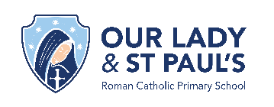

Subject statement of intent for Art and Design: At Our Lady and St Paul’s RC Primary School our intent is to deliver a high-quality art and design education that demonstrates to our children how art, craft and design expresses human creativity. We aim to engage, inspire and challenge our children, providing them with the knowledge and skills to experiment, invent and create their own works of art, craft and design. In developing their skills, our children should progress in being able to think critically and develop an understanding of art and design and how this both reflects and shapes our history, contributing to our culture and creativity. We aim to provide our children with the knowledge of great artists, craft makers and designers that will allow them to understand the historical and cultural development of these different art forms and inspire them as future professionals. We plan to provide a curriculum that ensures all children produce creative work, giving them the opportunity to explore their ideas and record their experiences. They should become proficient in the techniques for drawing, painting, sculpture, printing, textiles and digital media as well as evaluate and analyse their work using the correct vocabulary.

Statutory Requirements | KS1 | LKS2 | UKS2
Statutory Requirements | Pupils should be taught:  - to use a range of materials creatively to design and make products  - to use drawing, painting and sculpture to develop and share their ideas, experiences and imagination  - to develop a wide range of art and design techniques in using colour, pattern, texture, line, shape, form and space  - about the work of a range of artists, craft makers and designers, describing the differences and similarities between different practices and disciplines, and making links to their own work. | Pupils should be taught to develop their techniques, including their control and their use of materials, with creativity, experimentation and an increasing awareness of different kinds of art, craft and design.  Pupils should be taught:  - to create sketch books to record their observations and use them to review and revisit ideas  - to improve their mastery of art and design techniques, including drawing, painting and sculpture with a range of materials [for example, pencil, charcoal, paint, clay]  - about great artists, architects and designers in history.

KS1: Generating Ideas
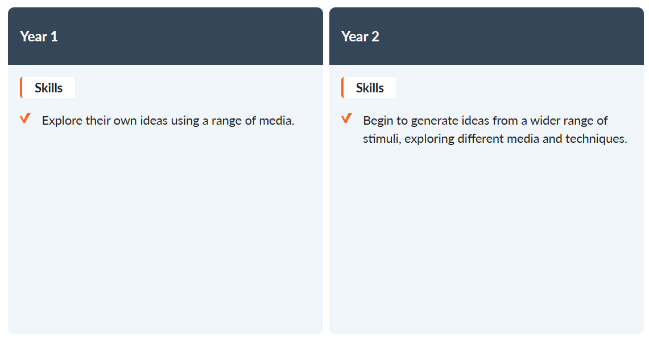

KS1: Using Sketchbooks
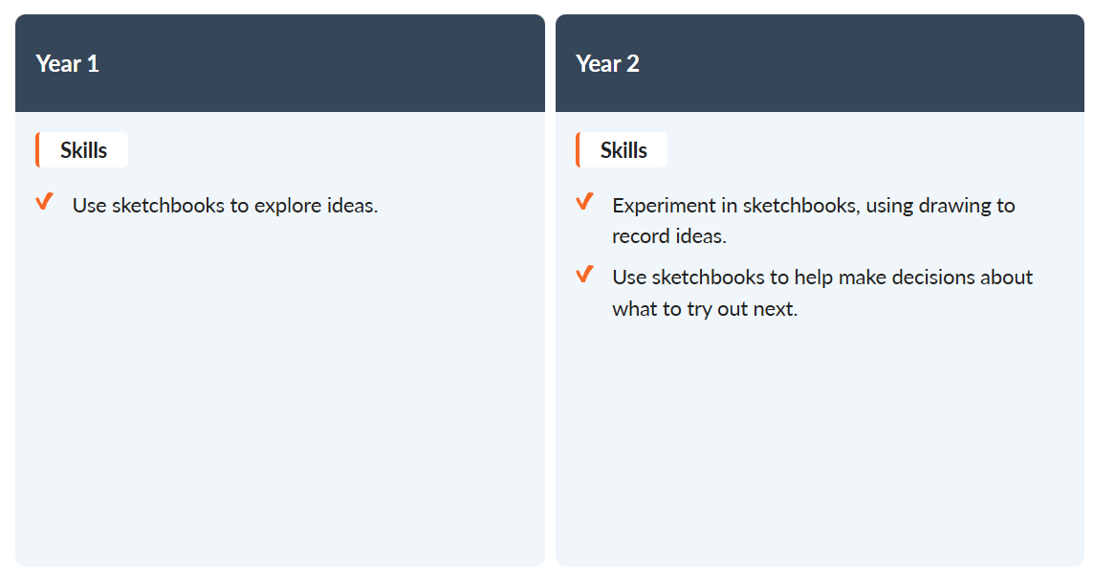

KS1: Making skills
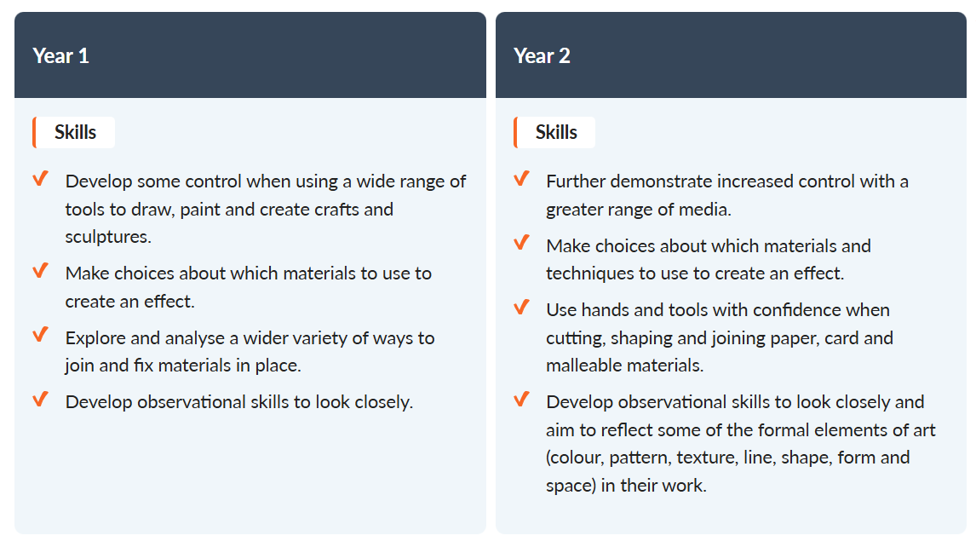

KS1: Knowledge of artists
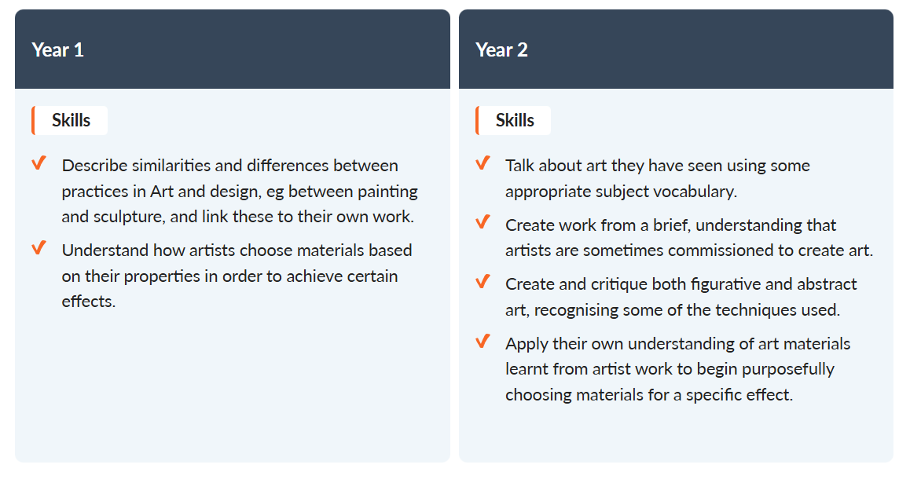

KS1: Evaluating and analysing
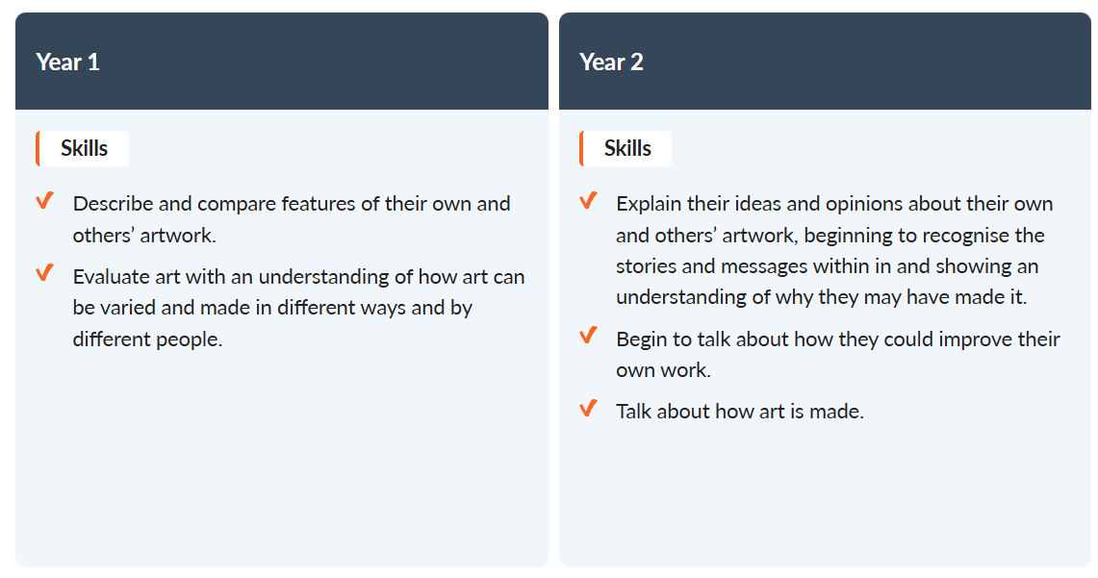

KS2: Generating ideas
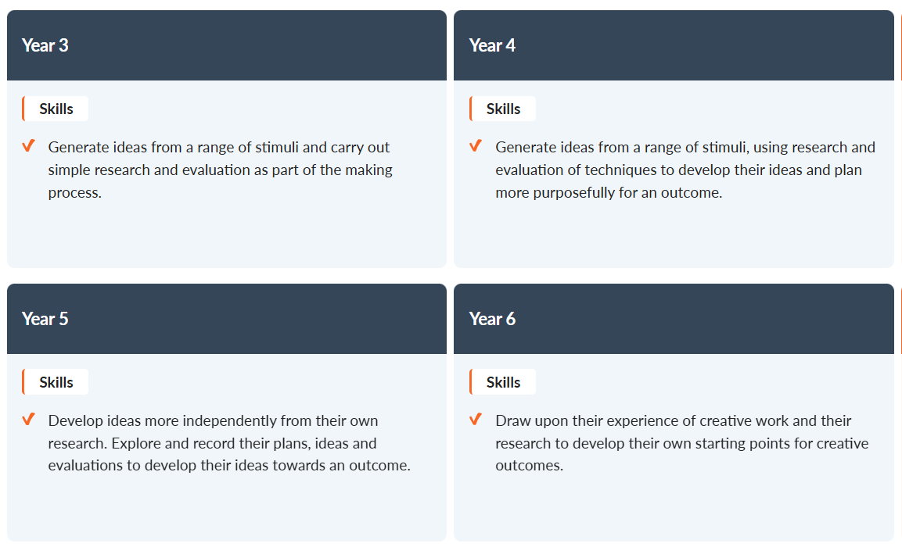
KS2: Using sketchbooks
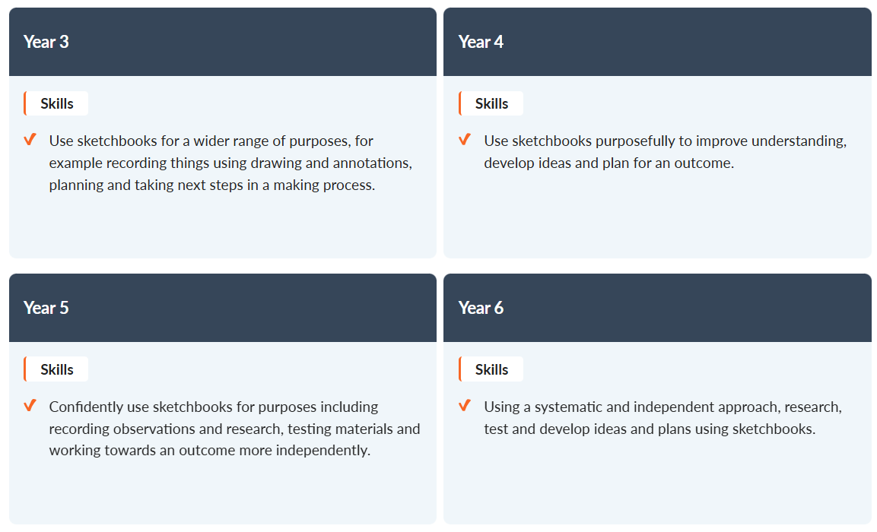
KS2: Making skills
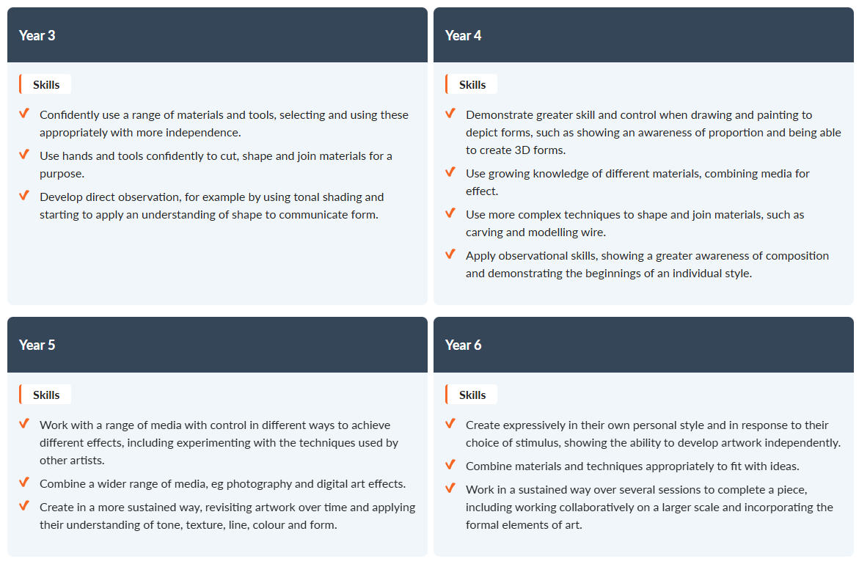
KS2: Knowledge of artists
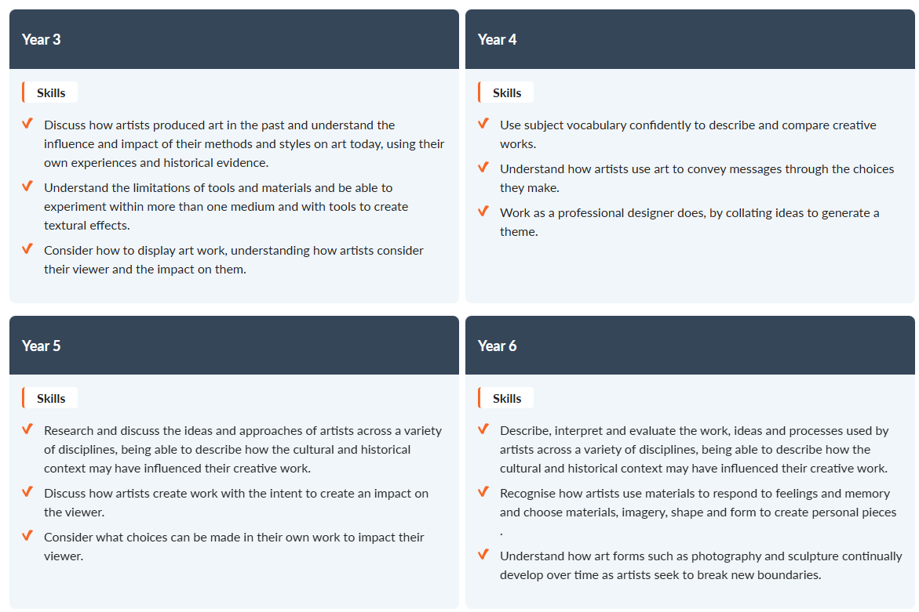
KS2: Evaluating and analysing
