Our Lady and St Paul’s RC Primary School

Subject statement of intent for Design Technology: At Our Lady and St Paul’s it is our intent to deliver a high-quality design technology programme that is inspiring, rigorous and practical. It will allow pupils to be creative and use their imaginations to design and make products that solve real and relevant problems within a variety of contexts, considering their own and others’ needs, wants and values. We aim to provide a curriculum where our pupils can acquire a broad range of subject knowledge and draw on disciplines such as mathematics, science, engineering, computing and art. We believe that providing these opportunities will allow our pupils to develop the skills needed to know how to take risks, becoming resourceful, innovative, enterprising and capable citizens. Through the evaluation of past and present design and technology, we aim to develop our pupil’s critical understanding of its impact on daily life and the wider world.
Statutory Requirements | KS1 | LKS2 | UKS2
Statutory Requirements | Through a variety of creative and practical activities, pupils should be taught the knowledge, understanding and skills needed to engage in an iterative process of designing and making. They should work in a range of relevant contexts [for example, the home and school, gardens and playgrounds, the local community, industry and the wider environment].  When designing and making, pupils should be taught to:  Design  - design purposeful, functional, appealing products for themselves and other users based on design criteria  - generate, develop, model and communicate their ideas through talking, drawing, templates, mock-ups and, where appropriate, information and communication technology  Make  - select from and use a range of tools and equipment to perform practical tasks [for example, cutting, shaping, joining and finishing]  - select from and use a wide range of materials and components, including construction materials, textiles and ingredients, according to their characteristics  Evaluate  - explore and evaluate a range of existing products  - evaluate their ideas and products against design criteria  Technical knowledge  - build structures, exploring how they can be made stronger, stiffer and more stable  - explore and use mechanisms [for example, levers, sliders, wheels and axles], in their products.  Cooking and Nutrition  - use the basic principles of a healthy and varied diet to prepare dishes  - understand where food comes from. | Through a variety of creative and practical activities, pupils should be taught the knowledge, understanding and skills needed to engage in an iterative process of designing and making. They should work in a range of relevant contexts [for example, the home, school, leisure, culture, enterprise, industry and the wider environment].  When designing and making, pupils should be taught to:  Design  - use research and develop design criteria to inform the design of innovative, functional, appealing products that are fit for purpose, aimed at particular individuals or groups  - generate, develop, model and communicate their ideas through discussion, annotated sketches, cross-sectional and exploded diagrams, prototypes, pattern pieces and computer-aided design  Make  - select from and use a wider range of tools and equipment to perform practical tasks [for example, cutting, shaping, joining and finishing], accurately  - select from and use a wider range of materials and components, including construction materials, textiles and ingredients, according to their functional properties and aesthetic qualities  Evaluate  - investigate and analyse a range of existing products  - evaluate their ideas and products against their own design criteria and consider the views of others to improve their work  - understand how key events and individuals in design and technology have helped shape the world  Technical knowledge  - apply their understanding of how to strengthen, stiffen and reinforce more complex structures  - understand and use mechanical systems in their products [for example, gears, pulleys, cams, levers and linkages]  - understand and use electrical systems in their products [for example, series circuits incorporating switches, bulbs, buzzers and motors]  - apply their understanding of computing to program, monitor and control their products.  Cooking and Nutrition:  - understand and apply the principles of a healthy and varied diet  - prepare and cook a variety of predominantly savoury dishes using a range of cooking techniques  - understand seasonality and know where and how a variety of ingredients are grown, reared, caught and processed.

KS1: Design
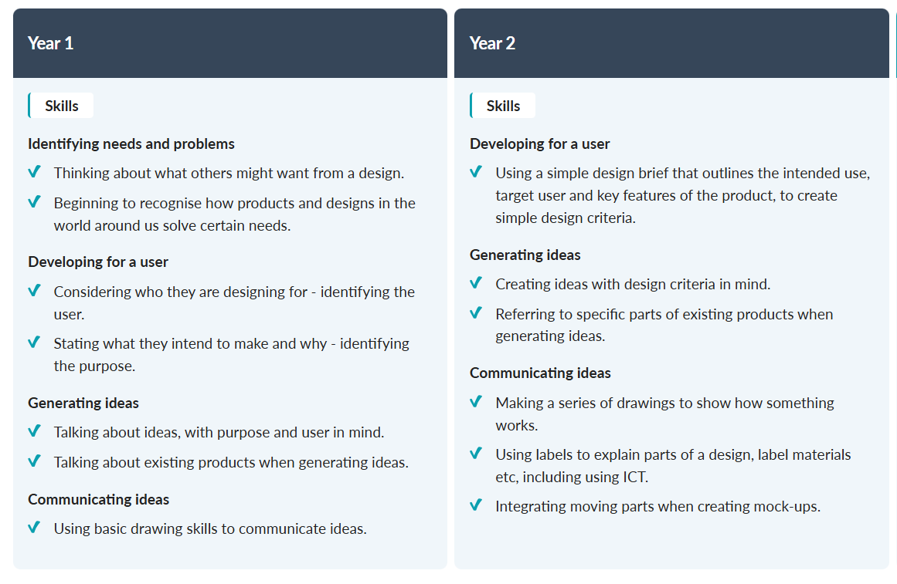
KS1: Make
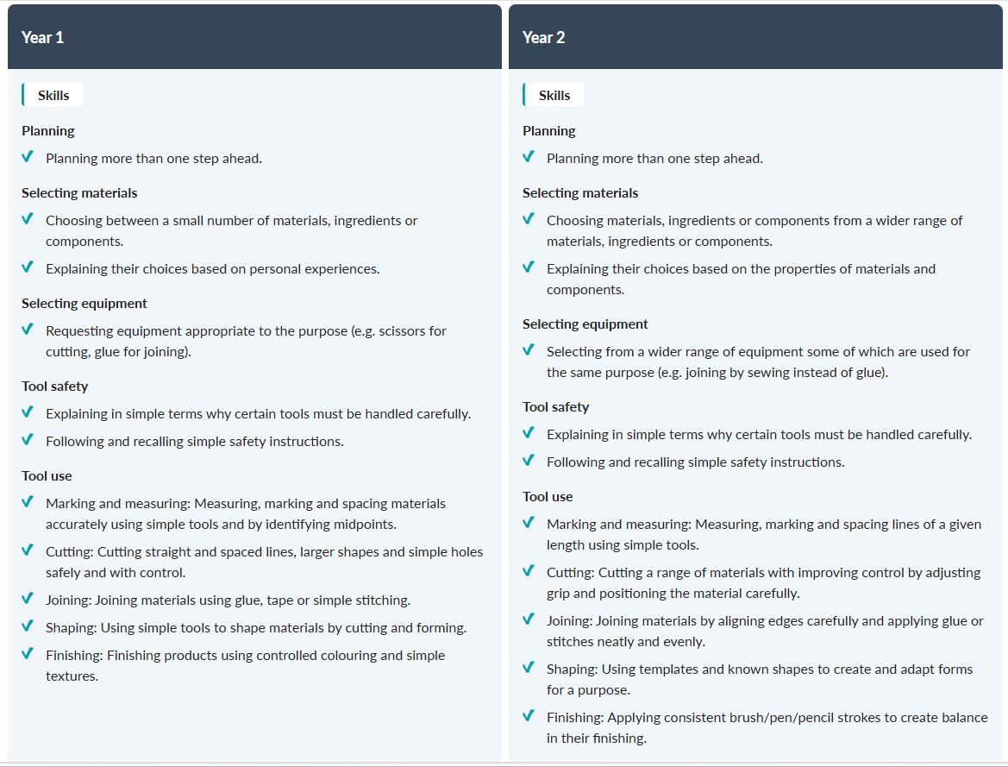
KS1: Evaluate
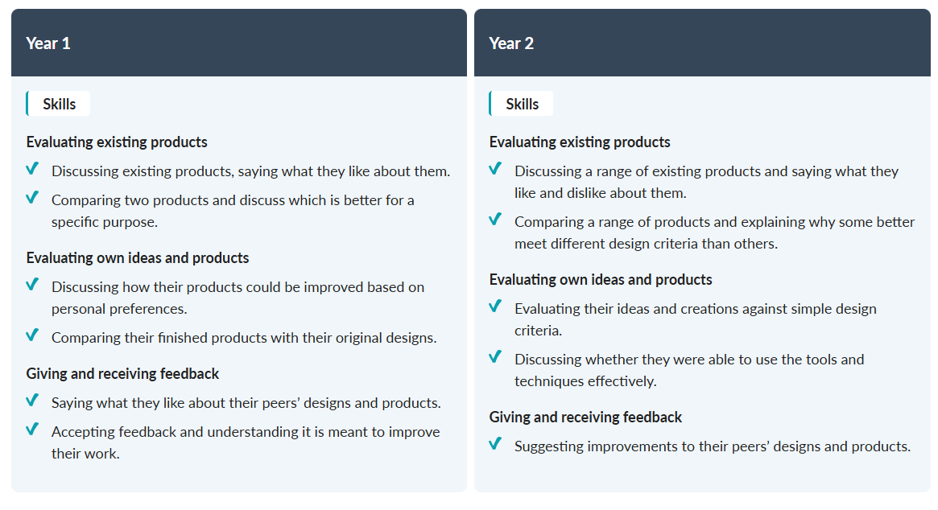

KS1: Technical Knowledge
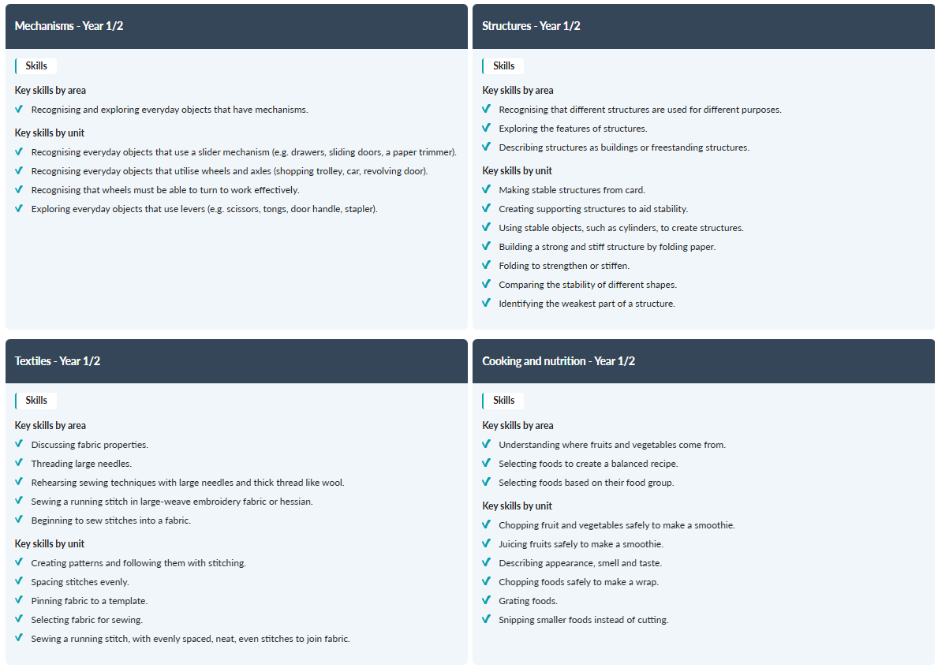
KS2: Design
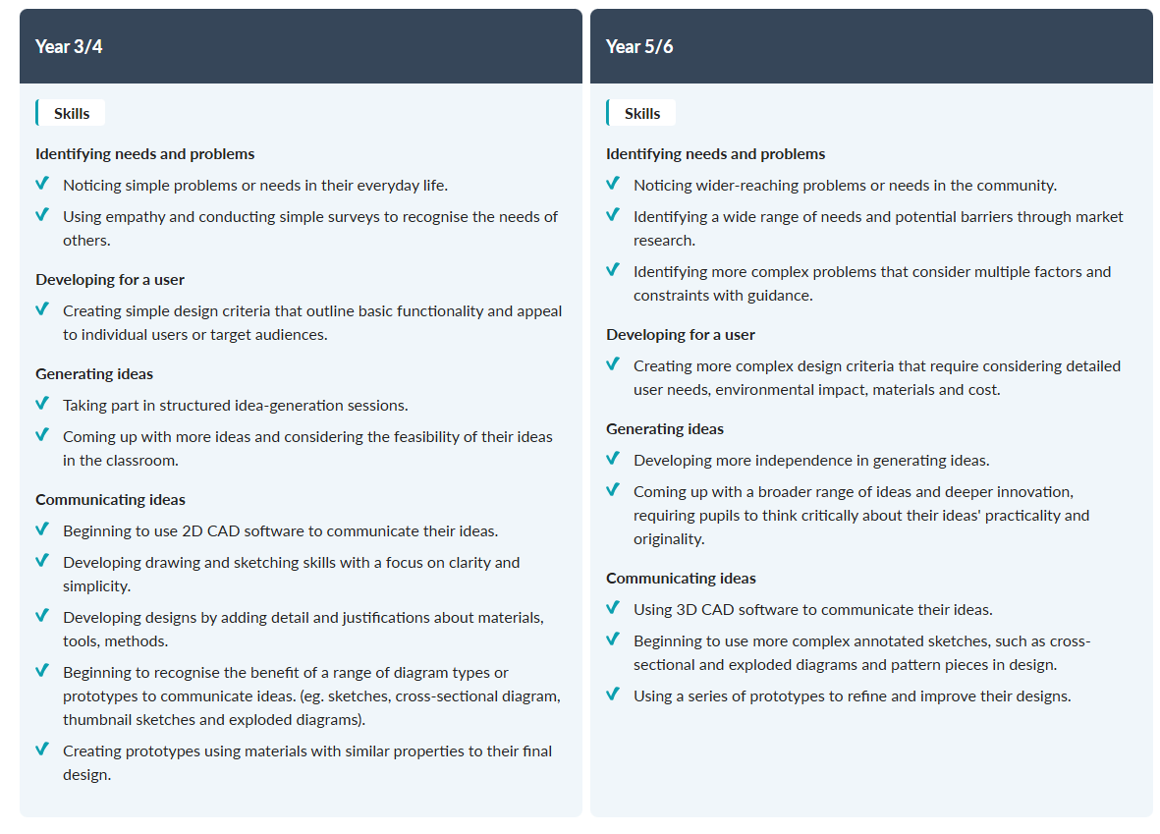
KS2: Make
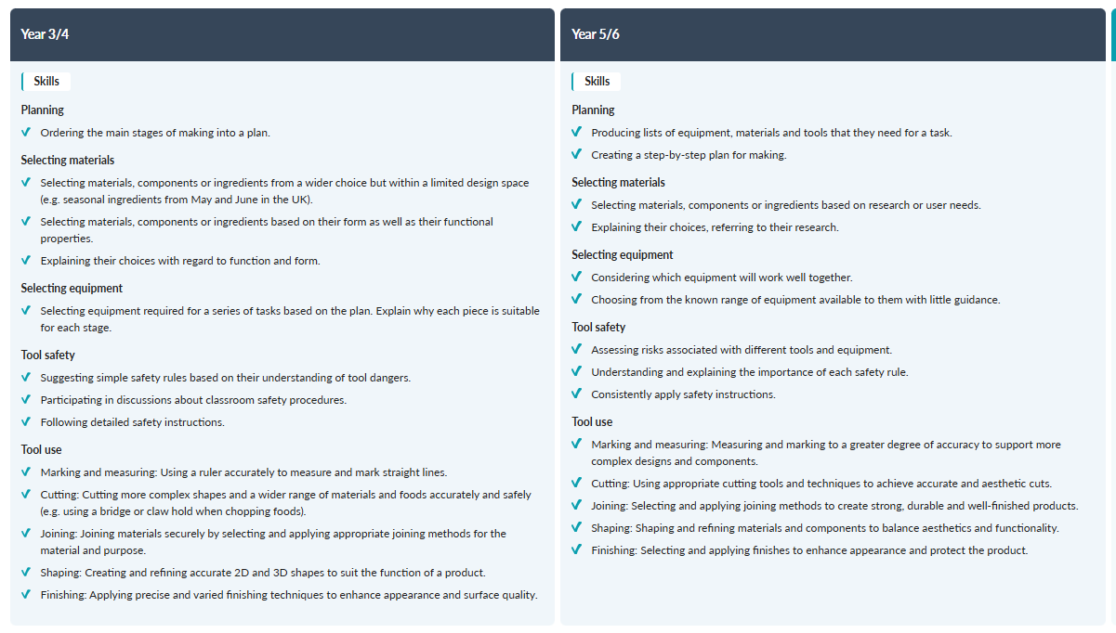

KS2: Evaluate
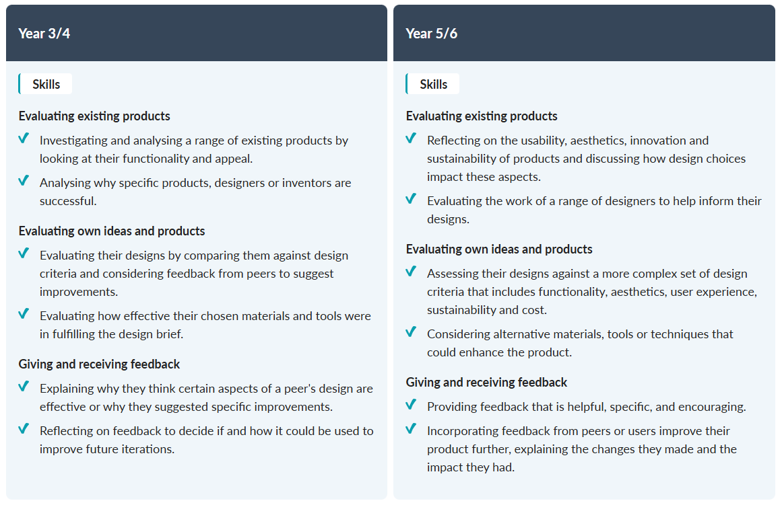
KS2: Technical Knowledge – Mechanisms
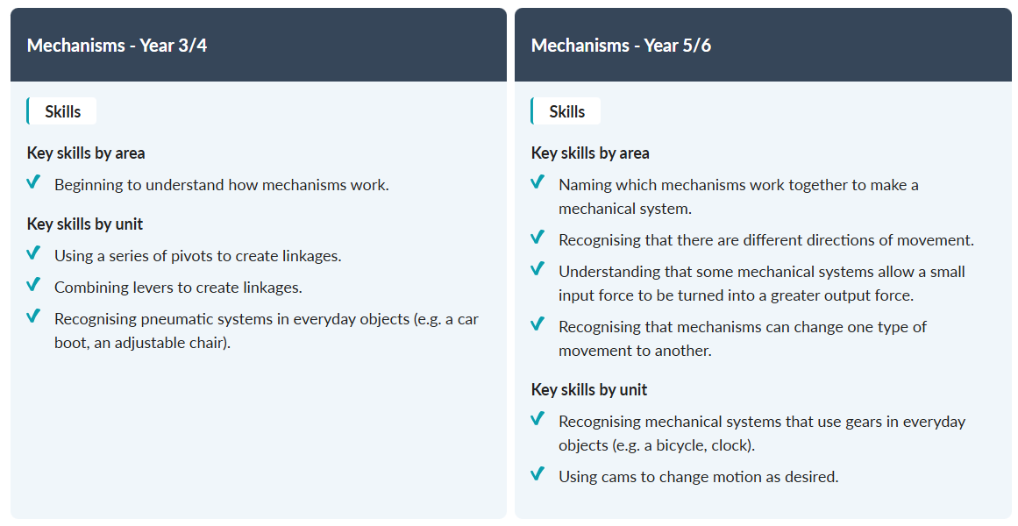

KS2: Technical Knowledge – Structures
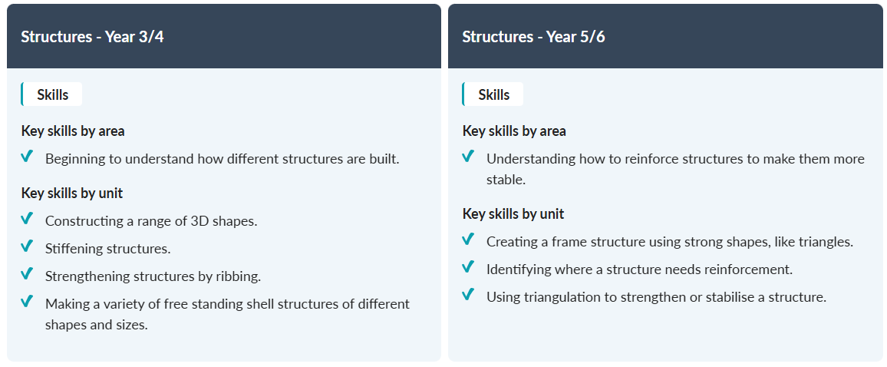

KS2: Technical Knowledge – Textiles
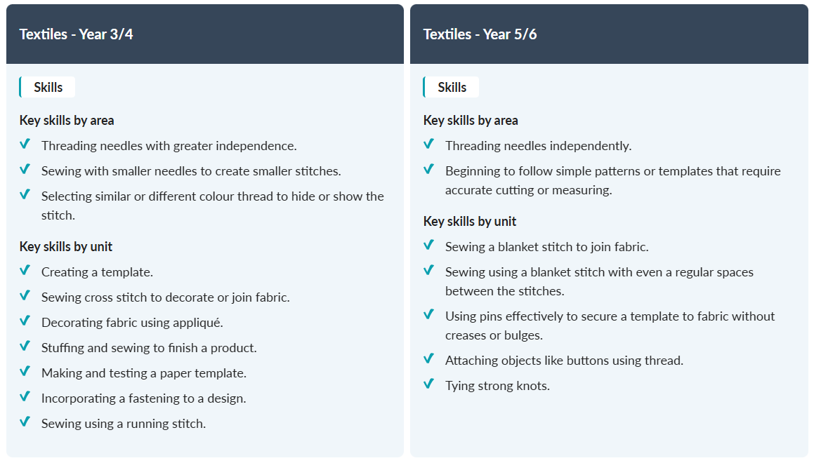

KS2: Technical Knowledge – Cooking and Nutrition
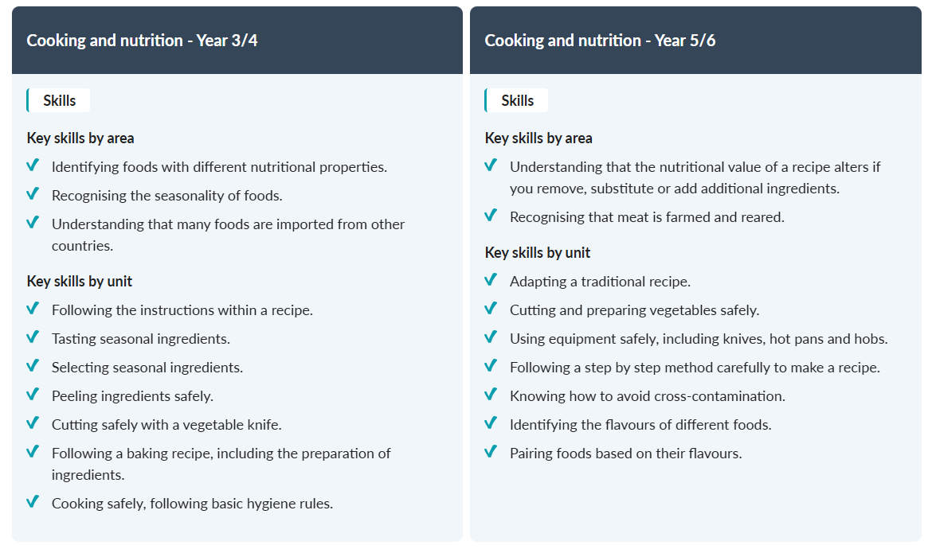
KS2: Technical Knowledge – Digital World
